**RFC-LFP004**

**Suggested problem**  
Kvitebjørn methodology (Cs-K mud) in LFP evaluations.  
  
  
**Suggested solution**

Use the Kvitebjørn workflow via the LogLan program cs_correction_v2.lls – see Figure 1.

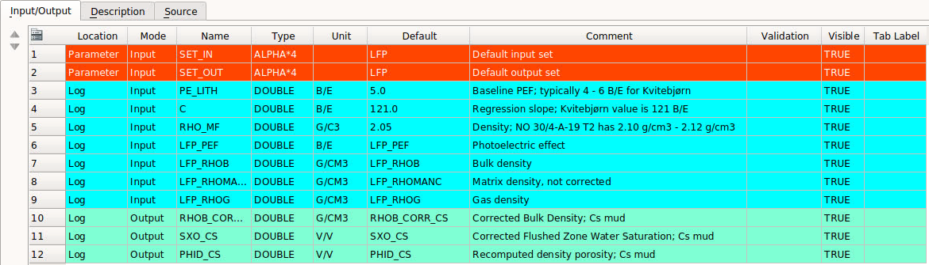  
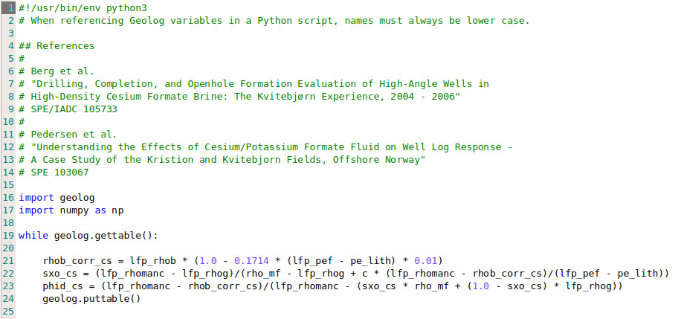  
Figure 1. Corrections done to RHOB and PHID by cs_k_formate_brine_corr.lls.

In the zone with Cs-K mud:

* put LFP_RHOBLOGFLAG = 0 and LFP_RHOB = LFP_RHOB_SYNT = RHOB_CORR_CS.
* Put LFP_MODELNC = 2
* Calculate effective GRDENS and and effective RHO_FL by cross plotting PHID_CSS vs RHOB_CORR_CS. See Figure 2 with example from NO 30/4-A-13. Thus RHOFLTG gets the value from the effective RHO_FL and LFP_RHOMANC gets the value from the effective GRDENS.
* Compare VSH with near-by wells without Cs-K mud in the same zone.

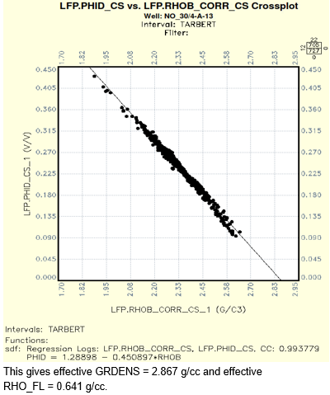  
Figure 1. Cross plot for well NO 30/4-A-13.

**GitHub Repository**

<https://github.com/equinor-inp/CsK_Format_Brine_Kvitebjoern>